**File:** **Vladimir_Yordanov_9_4bbed0.rb**

Task:

Develop a program named FirstName_LastName_ClassNumber_4bbed0.rb

1. you are given an argument for a folder with files;

1.1 if there are other arguments they should be discarded

2. file names in this folder are in the form First_Last_digits.rb;

3. find all the students that have 5 letters in their second name;

4. Sort the result by Last Name ASC.

5. Produce a result in CSV format named result.csv:

FirstName1,LastName1

FirstName2,LastName2

...

FirstNameN,LastNameN

Code:

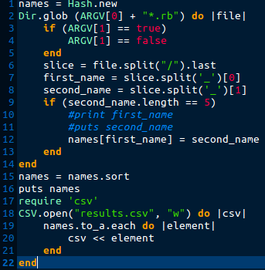

Errors:

* In line 9:in `block in <main>': undefined local variable or method `name' for main:Object (NameError)
* Check for files format is missing
* Unwanted output in terminal
* In line 18 wrong named CSV file, results.csv → result.csv
* CSV is sorted by first name instead of last name

New code:

